1) create a project folder (portfolio)

2) vs code terminal - npm create vite@latest . -- --template react
used vite its like a preinstalled template of react so when i put this cmd it automatically creates a skeleton of the project

3) installation of tailwind css

-[react - structure building , tailwind - adds style to structure]
-css is complicated whereas tailwind is easy than css
- to install tailwind and helper tools [npm install -D tailwindcss postcss autoprefixer]
-tailwind config files auto create - [npx tailwindcss init -p] but as im using v4 its bit different
for v4 of tailwind
-create css file in src folder called [index.css] and paste this [@import "tailwindcss"; (orr) @tailwind base;
@tailwind components;
@tailwind utilities;]
- link css to project open [main.jsx] file in src folder and add this or check if its there [import './index.css']
- run server [npm run dev]
-test - [src/app.jsx] and then change [vite+react] to [<h1 className="text-4xl font-bold text-blue-500">Hello Tailwind!</h1>]

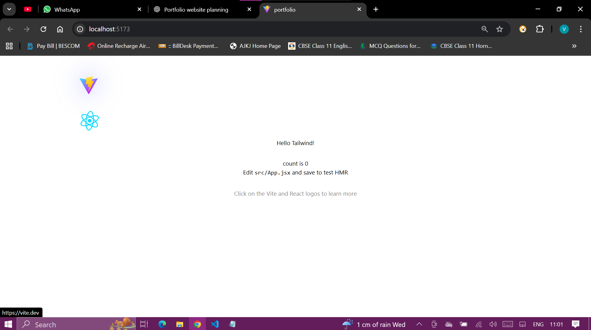

4) clear the default content in app.jsx file in src folder
import { useState } from 'react'
import reactLogo from './assets/react.svg'
import viteLogo from '/vite.svg'
import './App.css'
import react from 'react'
export default function App() {

return (
<div className="min-h-screen bg-gray-100 dark:bg-gray-900">
{/* Your portfolio will go here */}
</div>
)
}

5) create a folder components inside the src folder Components are like building blocks — reusable pieces of your website. For example: Navbar, Hero, Footer.
6) components/Navbar.jsx
import React from "react";
import Navbar from "./components/Navbar"; // Import Navbar

export default function App() {
return (
<div className="min-h-screen bg-gray-100 dark:bg-gray-900">
<Navbar /> {/* Show Navbar at the top */}
{/* Other sections (Hero, Projects, etc.) will go here */}
</div>
);
}

In app.jsx
import React from "react";
import Navbar from "./components/Navbar"; // Import Navbar

export default function App() {
return (
<div className="min-h-screen bg-gray-100 dark:bg-gray-900">
<Navbar /> {/* Show Navbar at the top */}
{/* Other sections (Hero, Projects, etc.) will go here */}
</div>
);
}

We render Navbar.jsx
Output:
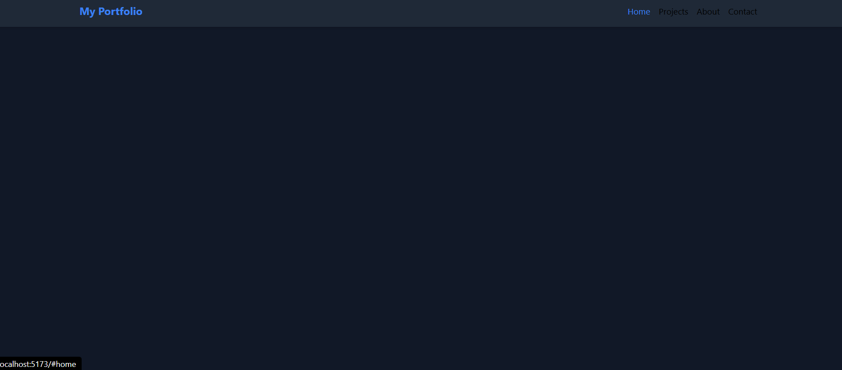

7) create a hero.jsx in components only add the code
And same way link it with app.jsx
import React from "react";

export default function Hero() {
// Dynamic content
const name = "Your Name";
const role = "Web Developer";
const tagline = "I build modern, responsive, and beautiful websites.";

return (
<section
id="home"
className="flex flex-col items-center justify-center text-center min-h-[80vh] bg-gradient-to-r from-blue-200 to-blue-400"
>
<h1 className="text-5xl font-bold mb-4">{name}</h1>
<h2 className="text-2xl font-semibold mb-6">{role}</h2>
<p className="text-lg max-w-xl">{tagline}</p>
</section>
);
}
This is hero.jsx
App.jsx
import React from "react";
import Navbar from "./components/Navbar";
import Hero from "./components/Hero"; // Import Hero

export default function App() {
return (
<div className="min-h-screen bg-gray-100 dark:bg-gray-900">
<Navbar />
<Hero /> {/* Hero section */}
{/* Other sections like Projects, About, Footer will go here */}
</div>
);
}

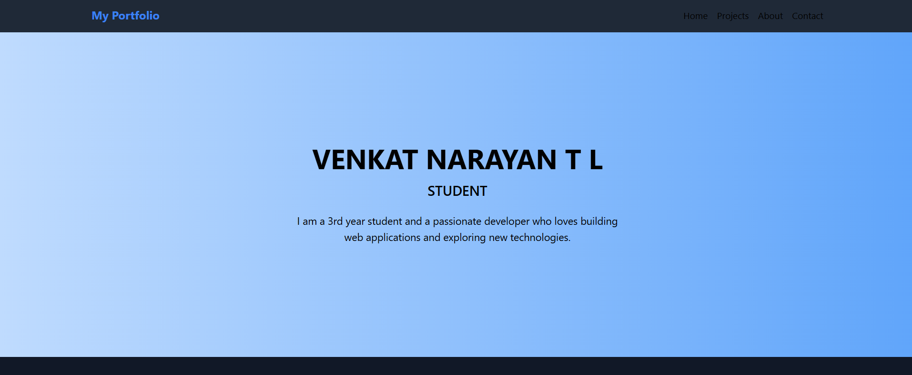

8) create project.jsx
import React from "react";

export default function Projects() {
// Dynamic projects array
const projects = [
{
name: "Portfolio Website",
description: "A personal portfolio website built with React and Tailwind CSS.",
link: "#",
},
{
name: "Todo App",
description: "A simple Todo app to manage daily tasks.",
link: "#",
},
{
name: "E-commerce Store",
description: "A responsive online store built with React and Firebase.",
link: "#",
},
];

return (
<section
id="projects"
className="py-16 px-4 bg-gray-100 dark:bg-gray-900"
>
<h2 className="text-4xl font-bold text-center mb-12">My Projects</h2>
<div className="grid gap-8 md:grid-cols-2 lg:grid-cols-3 max-w-7xl mx-auto">
{projects.map((project) => (
<div
key={project.name}
className="bg-white dark:bg-gray-800 p-6 rounded-xl shadow hover:shadow-lg transition"
>
<h3 className="text-2xl font-semibold mb-2">{project.name}</h3>
<p className="mb-4">{project.description}</p>
<a
href={project.link}
className="text-blue-500 hover:underline"
>
View Project
</a>
</div>
))}
</div>
</section>
);
}

And app.jsx
import React from "react";
import Navbar from "./components/Navbar";
import Hero from "./components/Hero";
import Projects from "./components/Projects"; // Import Projects

export default function App() {
return (
<div className="min-h-screen bg-gray-100 dark:bg-gray-900">
<Navbar />
<Hero />
<Projects /> {/* Projects section */}
{/* Footer will come later */}
</div>
);
}

Same thing with about and footer also

import React from "react";

export default function About() {
// Dynamic content
const aboutText = `Hi! I'm Your Name, a passionate web developer who loves building
modern, responsive, and user-friendly websites. I enjoy learning new technologies
and continuously improving my skills.`;

const skills = ["HTML", "CSS", "JavaScript", "React", "Tailwind CSS"];

return (
<section
id="about"
className="py-16 px-4 bg-white dark:bg-gray-800"
>
<h2 className="text-4xl font-bold text-center mb-8">About Me</h2>
<div className="max-w-3xl mx-auto text-center mb-8">
<p className="text-lg">{aboutText}</p>
</div>
<div className="max-w-3xl mx-auto flex flex-wrap justify-center gap-4">
{skills.map((skill) => (
<span
key={skill}
className="bg-blue-200 dark:bg-blue-700 text-blue-800 dark:text-blue-100 px-4 py-2 rounded-full font-semibold"
>
{skill}
</span>
))}
</div>
</section>
);
}

Footer.jsx
import React from "react";

export default function Footer() {
// Dynamic social links
const socialLinks = [
{ name: "GitHub", href: "https://github.com/yourusername" },
{ name: "LinkedIn", href: "https://linkedin.com/in/yourusername" },
{ name: "Twitter", href: "https://twitter.com/yourusername" },
];

const year = new Date().getFullYear(); // Current year

return (
<footer className="bg-gray-800 text-white py-6 mt-12">
<div className="max-w-7xl mx-auto flex flex-col md:flex-row justify-between items-center px-4">
<p>© {year} Your Name. All rights reserved.</p>
<div className="flex space-x-4 mt-4 md:mt-0">
{socialLinks.map((link) => (
<a
key={link.name}
href={link.href}
target="_blank"
rel="noopener noreferrer"
className="hover:text-blue-400"
>
{link.name}
</a>
))}
</div>
</div>
</footer>
);
}

And update app.jsx
import React from "react";
import Navbar from "./components/Navbar";
import Hero from "./components/Hero";
import Projects from "./components/Projects";
import About from "./components/About";
import Footer from "./components/Footer"; // Import Footer

export default function App() {
return (
<div className="min-h-screen bg-gray-100 dark:bg-gray-900">
<Navbar />
<Hero />
<Projects />
<About />
<Footer /> {/* Footer section */}
</div>
);
}

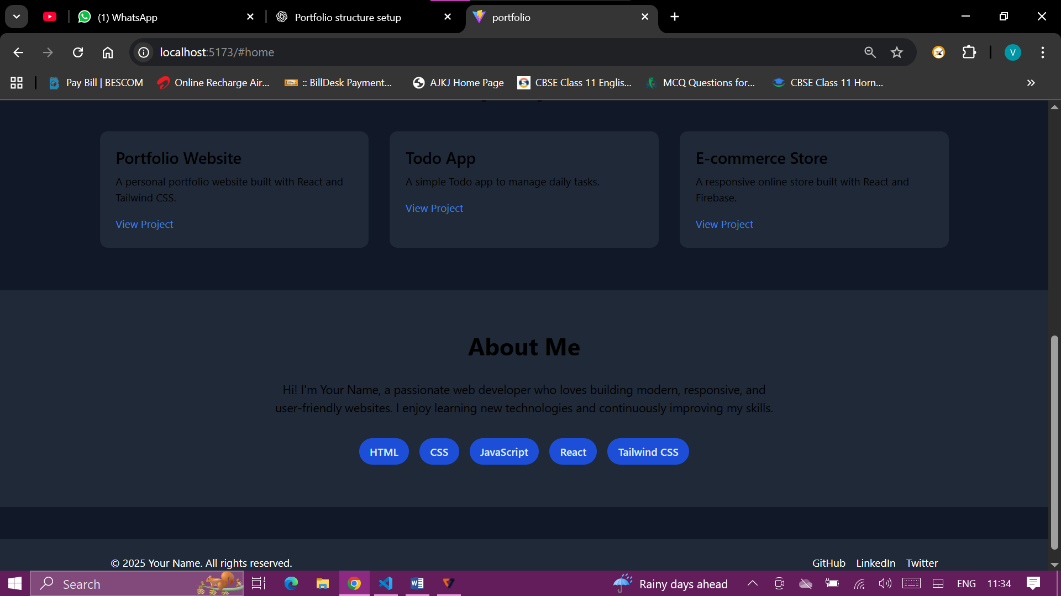

Update navbar etc to look more attractive … added trackers also to track leetcode and hackerrank
import React, { useEffect, useState } from "react";

export default function Trackers() {
const [stats, setStats] = useState({
leetcode: 0,
hackerrank: 0,
githubStars: 0,
});

// Later: API fetch can go here
useEffect(() => {
// Simulate fetching from API
setStats({
leetcode: 150,
hackerrank: 120,
githubStars: 45,
});
}, []);

const trackers = [
{ name: "LeetCode", value: stats.leetcode, icon: "🖥️" },
{ name: "HackerRank", value: stats.hackerrank, icon: "🏆" },
{ name: "GitHub Stars", value: stats.githubStars, icon: "⭐" },
];

return (
<section id="stats" className="py-16 bg-gray-100 dark:bg-gray-900 text-center">
<h2 className="text-4xl font-bold mb-12">Stats & Achievements</h2>
<div className="flex flex-wrap justify-center gap-8">
{trackers.map((t) => (
<div key={t.name} className="bg-white dark:bg-gray-800 p-6 rounded-xl shadow-lg w-48 hover:scale-105 transition-transform">
<div className="text-4xl mb-4">{t.icon}</div>
<h3 className="text-2xl font-bold">{t.value}</h3>
<p className="mt-2">{t.name}</p>
</div>
))}
</div>
</section>
);
}

